Precondition

Disassemble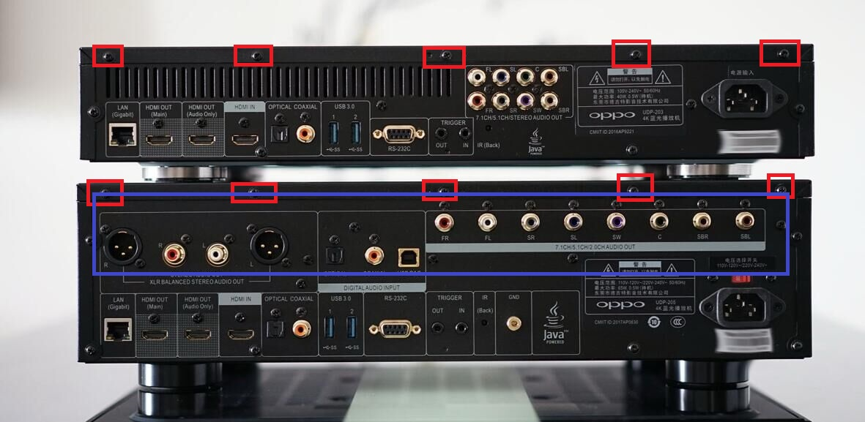

203 needs to remove 4 screws on both sides, as well as the red screw in the figure above.

205 needs to remove 4 screws on both sides, and the red screw in the figure above,as well as the screws in the blue box. Then remove the screws of the 2 audio boards, and be sure to be careful when removing the cable.

The flash port of the motherboard, the red box in the figure below.

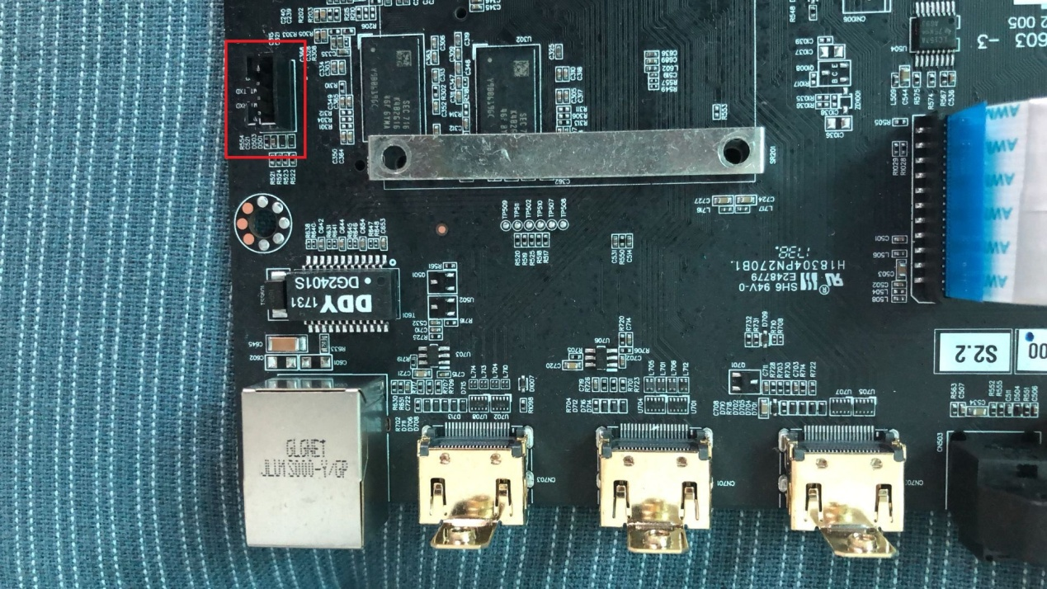

Computer side

1 Purchase of the serial board

buy usb-ttl

2 install driver

3 Check the serial number，(check drive success or not)

Computer - Property - Device Manager - Port

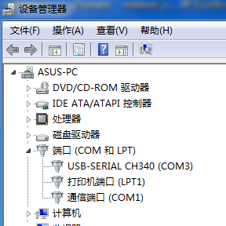

In the connection between the player and the serial port, do not connect the voltage wire. Only 3 wires need to be connected.

player serial port

GND GND

RX TX

TX RX

Then copy the UPG directory to the root directory of the U Disk with FAT32 format.

Next start the flash, be sure not to do any other redundant operations according to the instructions.

Electrify the player, but it is on the state of shutdown.

Open the MTKtool program, and check the information in the blue box carefully.

1 downgrade bootloader

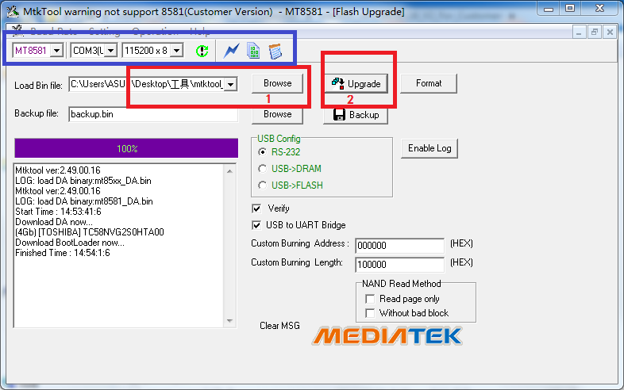

Click the “browse” in the 1 box, select the “downgrade.bin”, then click the “Update” in the 2 box, then press the power button to start up. Wait for the progress bar two times, after it is accomplished, remove the power wire of the machine, then plug in the power wire, do not turn it on.

2 install jailbreak firmware

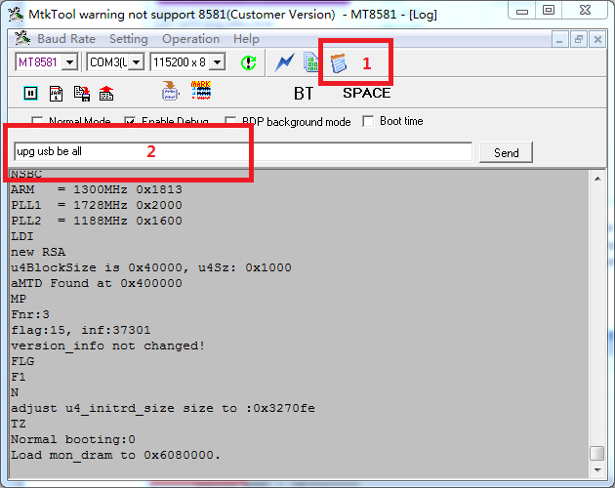

Then click the picture in the 1 box in the figure above to enter log mode. Hold the ENTER button of the computer, press the power button of the player to turn it on, Until the following content appears:

#

#

#

Release the ENTER button, enter the upg usb be all (lowercase) in the 2 box and then return, then wait. Until there is no more information to be printed, it is about four or five minutes, then the flash is finished.

Active .

Put the 0022DEXXXXXX.da1 to the root of usb stick.

Power on the player.plug the usb into the 20X usb ,see the volume.after 2 minutes.

Power off .power on ,enjoy.