User Manual – DRAM Monitor Tool
Erin Lo
2009/06/28

- Introduction
There are many H/W assembled in MT8530. Some of them can access DRAM directly through DRAMC, and RISC is just one of them. Now we introduce a useful tool, DRAM Monitor, which could roughly monitor the DRAM usage in MT8530 and help us to know the DRAM request statistics. This document describes the usage of the tool.

The DRAM Monitor is integrated into MTKTool after version 2.47.01.12. Please check that you have the correct MTKTool program. You can find the MTKTool, mtktool_ver2.47.01.12.zip, in the “000. Files” folder under “SA Experience Share/ 007.Tools”.

圖更新

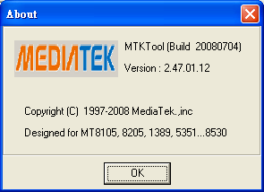

- Usage
  - Execute the MTKTool in “prassi” mode.
  - Choose Chip ID MT8530
  - Click the DRAM Monitor button in Operation -> DRAM Monitor, then the DRAM Monitor user interface will appear.
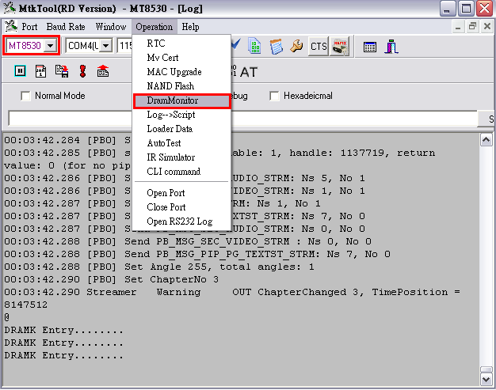

  - Users can freely choose channel 1, channel 2, or both to monitor via clicking the checkboxes. It will show which HW exactly use DRAM, but the percentage not means the precisely data number just the roughly numbers, since the percentage include physical communicate time. If you want to know the precisely number please use CLI. ps1.
  - After clicking the “Start” button, the DRAM request statistics will start immediately.
  - If you want to stop the statistics, just click the “End” button.
  - If you want to restart the statistics, click the “Reset” button.

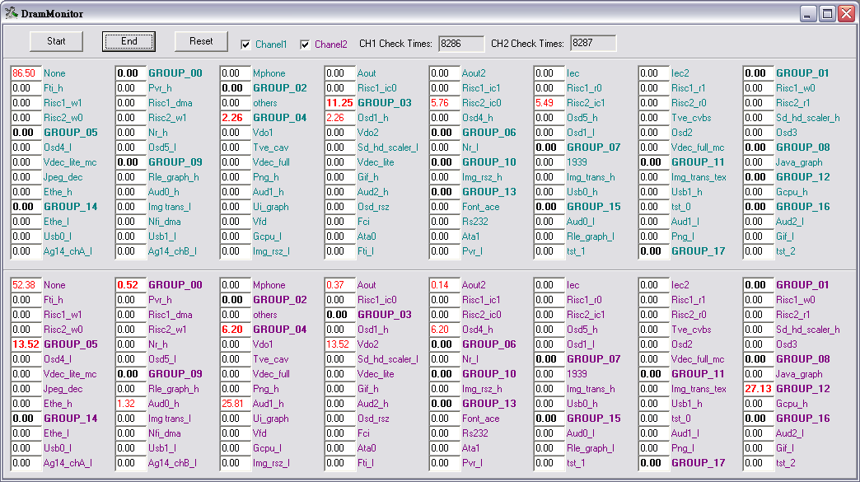

http://pm/sites/projectserver_353/Public/SA%20Experience%20Share/005.Debug/016.How%20to%20Monitor%20DRAM%20via%20RISC%20–%20MT8530%20DRAM%20Monitor%20CLI.doc

