**Part 1 - UDP-20x Preparation:**

**Disassemble the Oppo UDP 203/205 to expose the “flash port” on the motherboard:**

First, Unplug the UDP-20x power cable.

**UDP-203:** Remove the two screws from both sides of the player. Remove the four screws in the red boxes on the back of the player (as seen in the figure below). Finally, pull the top cover off by lifting slightly from the rear while pulling backwards.

**UDP-205:** Next, remove the two screws from both sides of the player. Remove the five screws in the red boxes from the back of the player (as seen in the figure below). Then pull the top cover off by lifting slightly from the rear while pulling backwards. On the UDP-205 both audio boards need to be removed. Removal includes the ribbon cables as well as the clip on cables. You will need to remove the screws from the back of the player for all of outputs. Remove the shiny silver screws that hold the boards in place inside the player. NOTE: Be very careful with the ribbon cables as they can take quite a bit of force to remove (and to reinstall), but they are also fragile. Use evenly applied force when removing the cables and make absolutely certain they are centered when they are reinserted during reassembly.

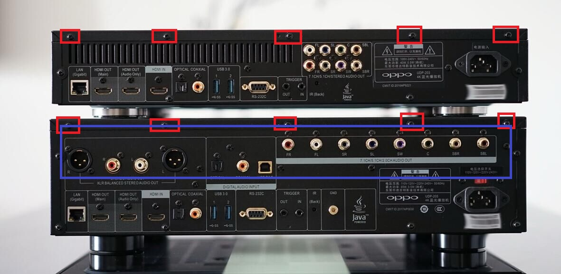

The flash port on the motherboard is located in the red box shown in the figure below. It is very close to the LAN network connector.

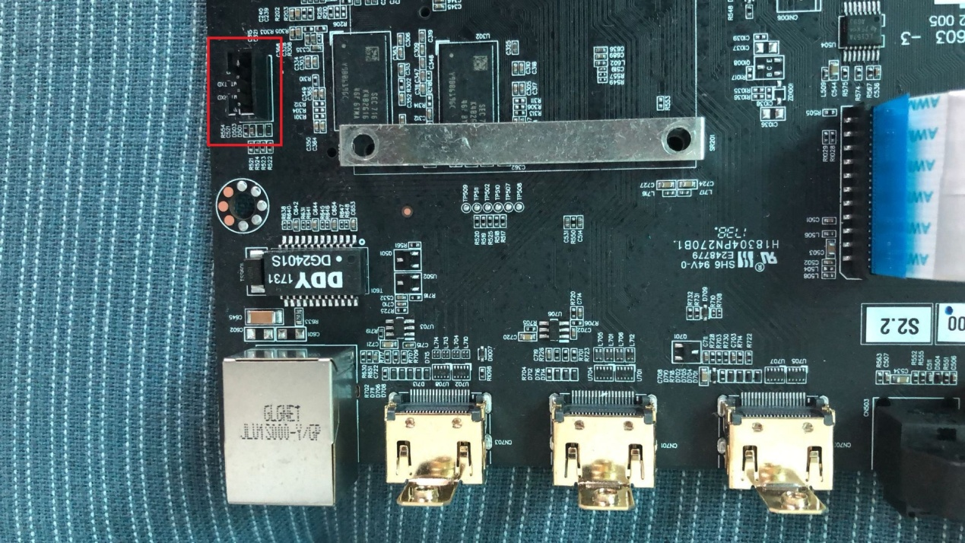

Page 1 of 5

**Part 2 - Hardware Programmer and Computer Preparation:**

First, you must purchase a CH340 USB to TTL converter module. These can easily be bought on eBay, Amazon, or AliExpress. Just search your preferred site for “CH340 USB TTL.” They only cost a few dollars.

**Before inserting the programmer into your PC’s USB port, you must install the driver.** To install the driver, simply run the “CH340 DRIVER.EXE” file included with this package and follow the prompts. Once the driver has been installed, insert the USB programmer into your PC.

Windows will install the programmer using the drivers you just installed. Once the programmer is installed open device manager and expand the “Ports (COM & LPT)” to verify that the programmer is properly installed. Write down or make a mental note of what COM port number the serial programmer is assigned to. In the case shown in the figure below, the programmer is using COM port 3 (COM 3).

Computer > Properties > Device Manager > Ports

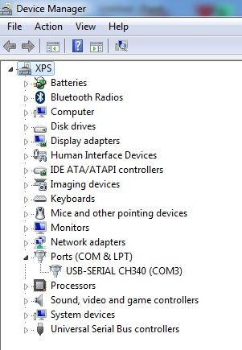

Page 2 of 5

**Part 3 – Connecting the Programmer to the Oppo UDP Player:**

**Firstly, do not connect voltage or power between the programmer and the Oppo UDP player.** Only 3 wires should be connected. The three wires are listed and diagrammed below. **Note that the RX and TX must be crossed between the programmer and the UDP player.** If you accidentally connect TX to TX and RX to RX you will not hurt the player, but programming will fail.

Connect the programmer to the player.

UDP Player: Programmer:

GND ------------- GND

RX ---------------- TX

TX -----------------RX

Finally, format a small USB flash drive using the **FAT32 format** then copy the UPG directory included in this package to the root directory of your USB disc. Insert the USB disc in the front USB port of the UDP player.

**Part 3 – Programming the UDP with the New Firmware:**

**Follow these instructions exactly or you can easily brick your player! If you brick the player you will need to send it back to Oppo for repair.**

First, plug the UDP into wall power using the player’s power cord. **Do not turn on the player.** You should see only the red standby light on the front of the player.

Next, open the MTKtool program included with this package. Verify that the information in the blue box is the same as in the figure below, except make sure the COM port matches your programmer’s COM port that you noted earlier in device manager.

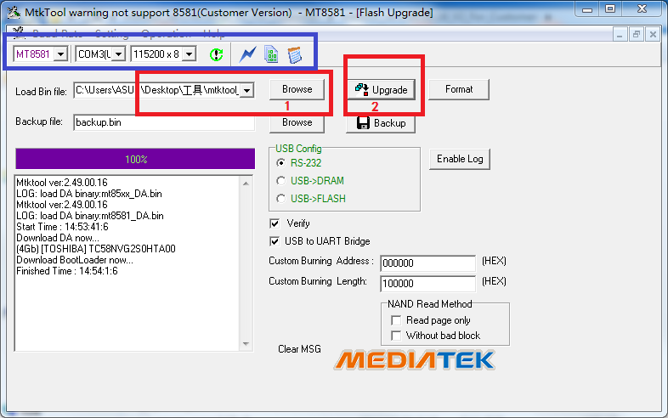

Click “Browse” in red box 1 in the figure above, and browse to then select the “downgrade.bin” file included in this package. Then click the “Update” icon in the red box 2. After that, press the power button

Page 3 of 5

on the UDP to start it up. The boot loader will begin to program on its own. Wait for the progress bar to pass two times; the first pass is to program and the second pass is to verify the programming success. Once that is finished, remove the power cable from the UDP player. Wait 20 seconds or more and then plug the power cable back into the player. **DO NOT TURN ON THE PLAYER!** You should again see the red standby LED on the front of the UDP.

Now it is finally time to install the jailbreak firmware. As shown in the figure below, click the notebook picture icon inside red box 1 to enter log mode. Then press and hold down the ENTER button on your computer. While holding ENTER down press the power button on the UDP player to turn it on (continue to hold the ENTER button on your computer). Once you see the following content appears in the MTKtool software log:

#

#

#

Release the ENTER button on your computer once you see the “#” symbols appearing (there may be some characters after the “#”). At this point, type “upg” (lowercase without “quotes”) as shown in red box 2 in the figure below, and then click “Send.” This will start the programming. Wait about five minutes until there is no more information appearing in the MTKtool log screen.

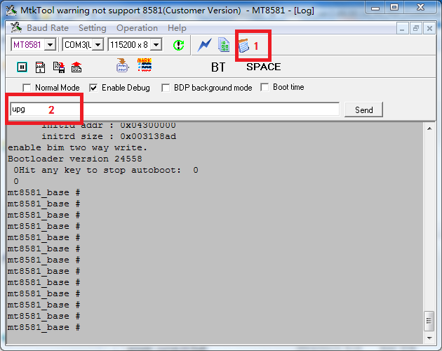

Page 4 of 5

Lastly, the boot loader must be “upgraded.” Click the blue lightning bolt icon inside of the blue box in the figure below.

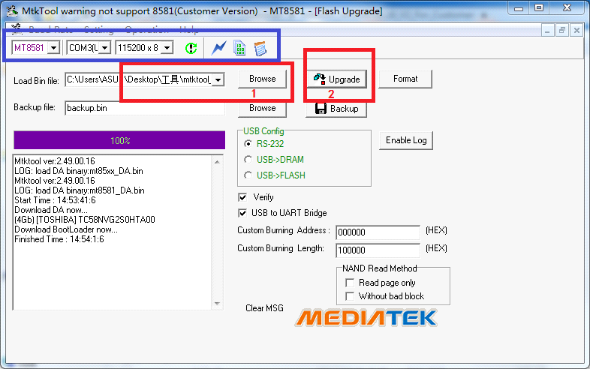

Click the “browse” button in red box 1 and select the “upgrade.bin” file. Once ‘upgrade.bin is selected, click the “Update” button in red box 2. Press the power button on your UDP to start up the player. The boot loader will start to program once the player is powered up. Again, wait for the progress bar to pass twice; once for programming and once to verify. Unplug the player’s power cable, wait 20 seconds, and plug the player back in, but do not turn it on.

Congratulations, you are finished programming.

Format a USB flash drive using the **NTFS format** and copy your “access key” file to the USB disc. This USB disc must be in the player at all times for the jailbreak to work. Insert the USB flash drive into the player with the *.DAT access key file, power up the player, and verify jailbreak functions such as ISO playback.

Once successful, put your player back together.

These English instructions were edited by Craig Rounds of CIR-Engineering in order to make programming easier to follow for English readers.

CIR-Engineering

[www.cir-engineering.com](http://www.cir-engineering.com)

[craigr@cir-engineering.com](mailto:craigr@cir-engineering.com)



Page 5 of 5